**GITHUB – PART 3**

**How to fork a repository and commit the fork repository and create a pull request.**

Open the link:  <https://github.com/romeokienzler/TensorFlow/>

Click ‘Fork’ and copy the repository in your account.

Copy the SSH Repository Link and clone it locally using:

git clone yoursshrepolink

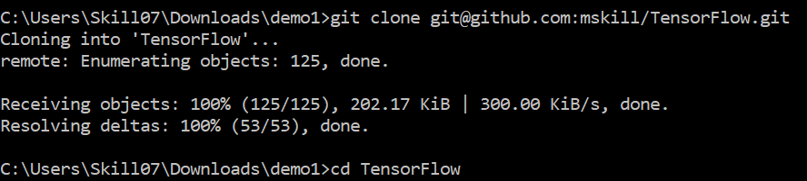

Open and edit any file in the editor.

After saving the file,

git add .

And commit the changes with the message:

git commit -m “message”

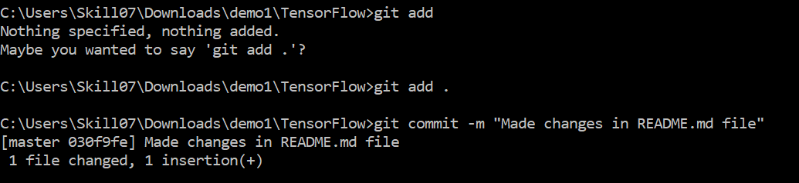

git push to make the changes in remote repository

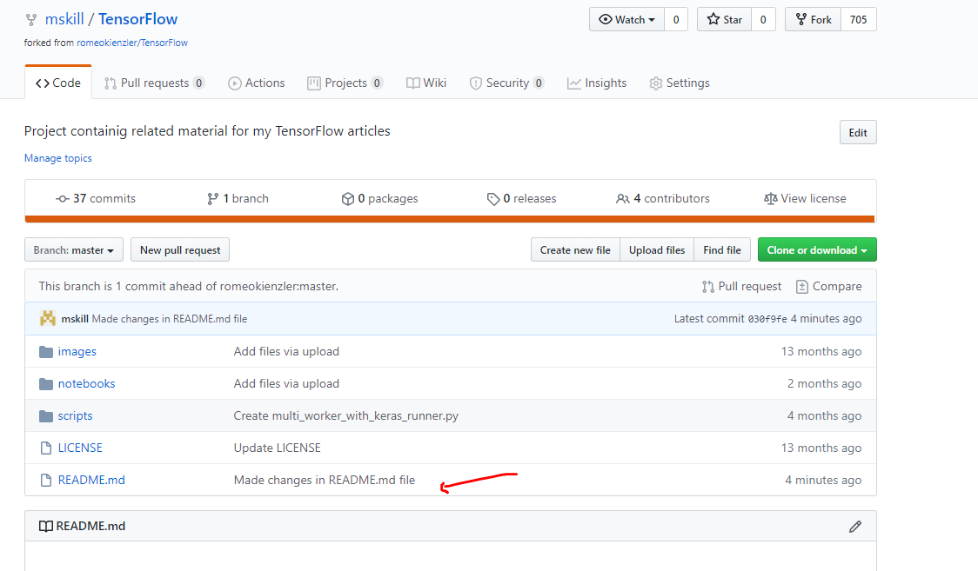

Click ‘Compare’ to compare the changes.

**NOTE: This request will go to AUTHOR of the repository and if the changes looks good, only then the original repository can get the changes.**

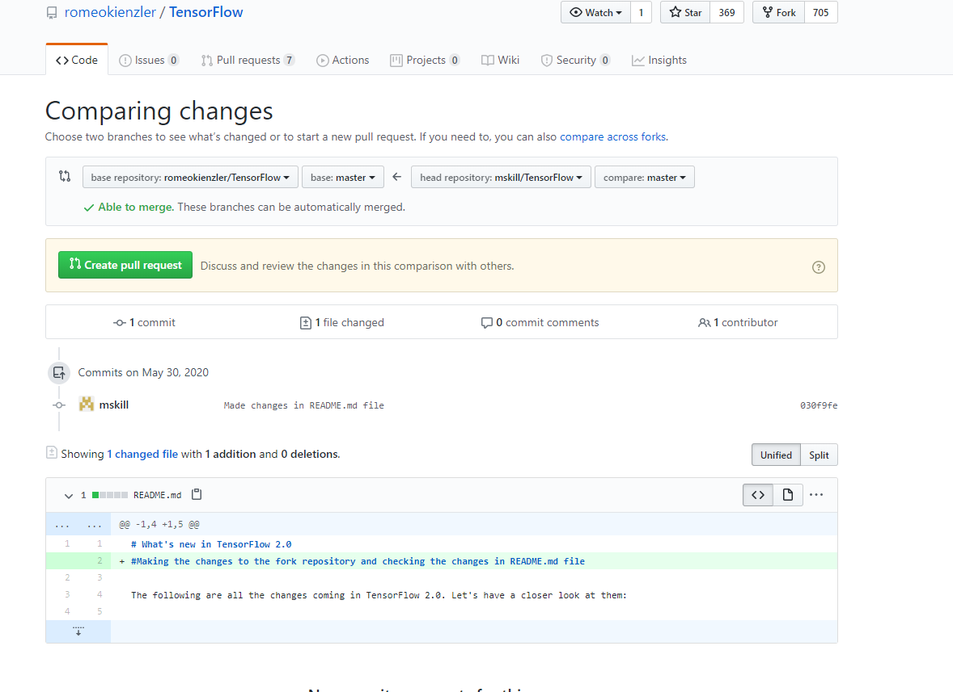

Create a Pull request to make the changes in the original file.

Note: The pull request will now send to the author of the repository and if accepted the changes will be made to the original repository.